

MACQUARIE UNIVERSITY

**Faculty of Science and Engineering**

**Department of Computing**

**ISYS224/ITEC624 Database Systems 2019 (Semester 2)**

**Assignment 2 (Report)**

**Database Programming and Implementation (worth 15%)**

**Student Name: Justin Lam**

**Student Number: 45197083**

**Student Declaration:**

*I declare that the work reported here is my own. Any help received, from any person, through discussion or other means, has been acknowledged in the last section of this report.*

Student Signature:

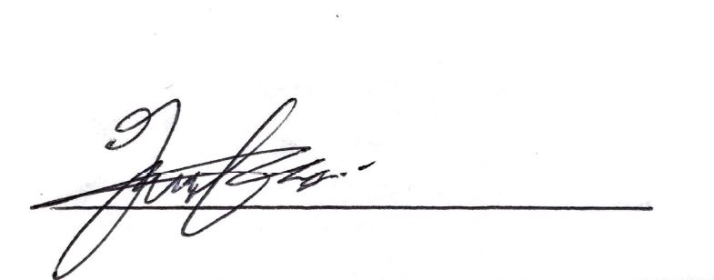

Student Name and Date: Justin Lam (23/10/2019)

1. **Initial State of the database**

Staff Table

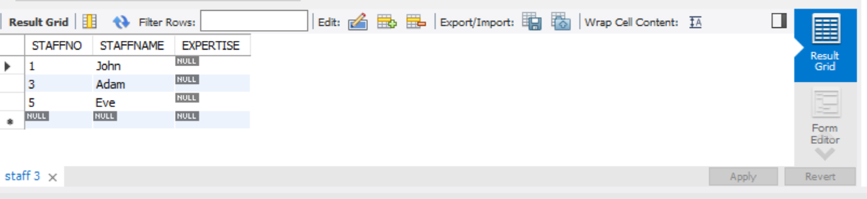

Customer Table

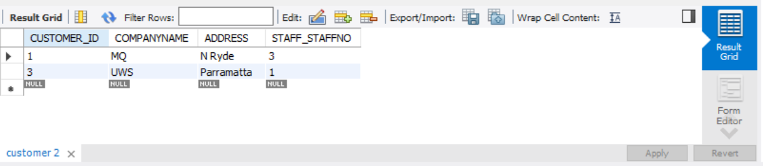

Campaign Table

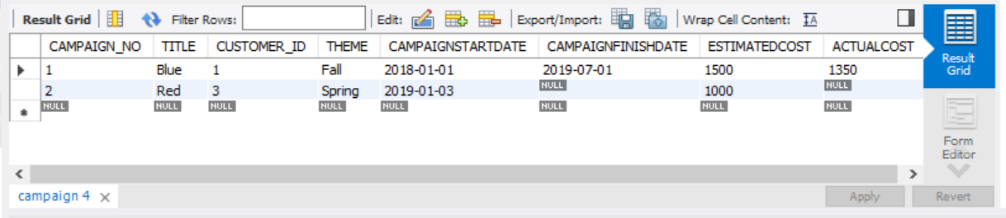

Invoice Table

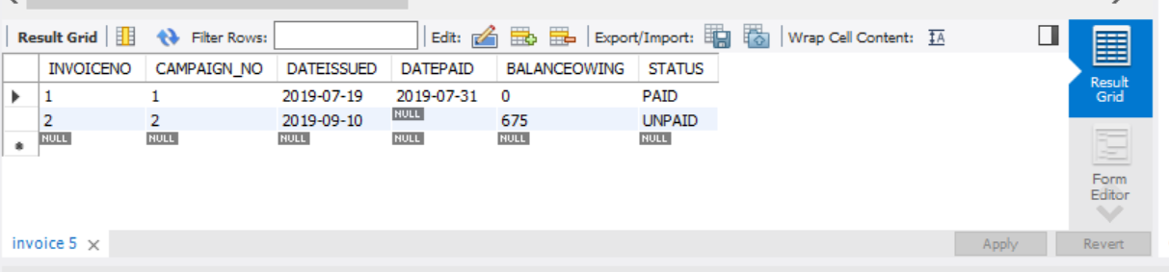

SalaryGrade Table

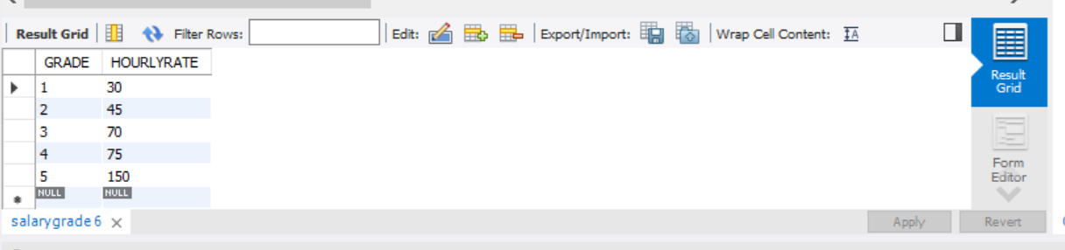

StaffonGrade Table

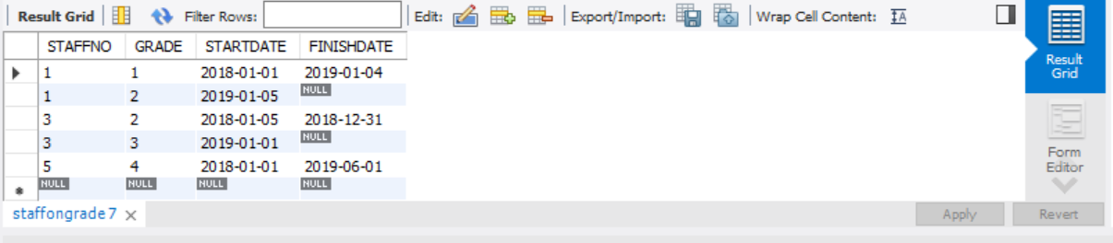

Works on Table

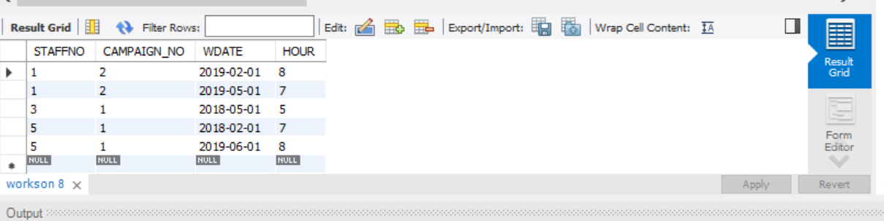

1. **Stored Programs.**

**Trigger 1 (tr_overdue) code**

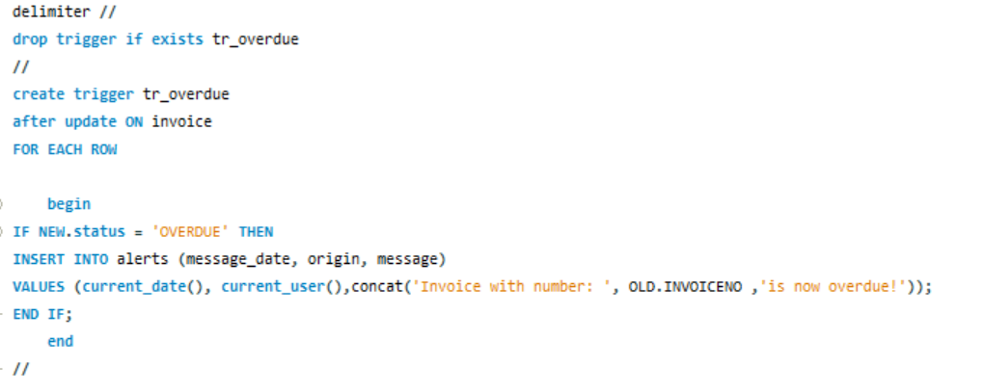

**Function 1 (rate_on_date) Code**

DELIMITER //

drop function if exists rate_on_date //

create function rate_on_date(staff_id int, given_date DATE)

returns float

deterministic

BEGIN

DECLARE hourly_rate float;

DECLARE r_hour cursor for

SELECT HOURLYRATE

FROM staffongrade, salaryongrade

WHERE STAFFONGRADE.GRADE = SALARYONGRADE.GRADE

AND WORKSON.STAFFNO = staff_id

AND given_date >= STARTDATE and (FINISHDATE is NULL or given_date <= FINISHDATE);

open r_hour;

fetch r_hour into hourly_rate;

close r_hour;

RETURN hourly_rate;

END //

**Function 2 (cost_of_campaign) Code**

drop function if exists cost_of_campaign //

create function cost_of_campaign (camp_id int)

returns float

DETERMINISTIC

begin

declare staff_id int;

declare work_date date;

declare hours float;

declare t_cost float;

declare hand int default 0;

declare c_cursor cursor for

select staffno, WDATE, 'Hours'

from workson

where CAMPAIGN_NO = camp_id;

declare continue handler for not found set hand = 1;

open c_cursor;

set t_cost = 0;

while hand != 1 DO

fetch c_cursor into staff_id, work_date, hours;

set t_cost = t_cost + (hours * rate_on_date (staff_id, work_date));

end while;

close c_cursor;

RETURN t_cost;

END //

**Stored Procedure 1 (sp_finish_campaign) Code**

Delimiter //

drop procedure if exists sp_finish_campaign //

create procedure sp_finish_campaign (in c_title varchar(30))

begin

declare number_of_campaigns int;

select COUNT(campaign.CAMPAIGN_NO) into number_of_campaigns from campaign WHERE campaign.TITLE = c_title;

if number_of_campaigns = 0 then

select 'ERROR! Campaign title does not exist' as 'msg';

elseif number_of_campaigns = 1 then

update campaign

set

campaign.CAMPAIGNFINISHDATE = CURRENT_DATE(),

campaign.ACTUALCOST = cost_of_campaign(campaign.CAMPAIGN_NO)

where campaign.TITLE = c_title;

end if;

end //

Delimiter ;

**Stored Procedure 2 (sync_invoice) Code**

Delimiter //

DROP PROCEDURE IF EXISTS sync_invoice //

--

CREATE PROCEDURE sync_invoice()

BEGIN

UPDATE invoice

SET invoice.STATUS = 'overdue'

WHERE invoice.DATEISSUED + 30 <= CURRENT_DATE()

AND invoice.DATEPAID IS NULL;

SELECT ROW_COUNT() AS 'Number of invoices updated.';

END //

DELIMITER ;

1. **Required Testing against Sample Database.**

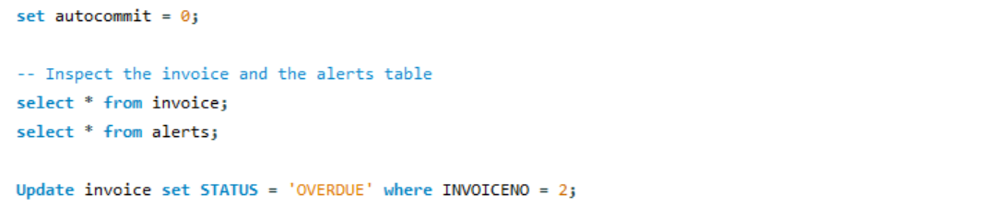

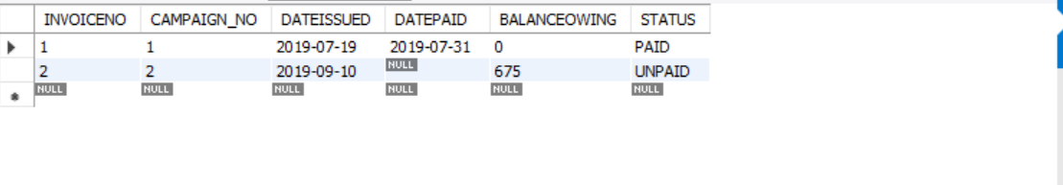

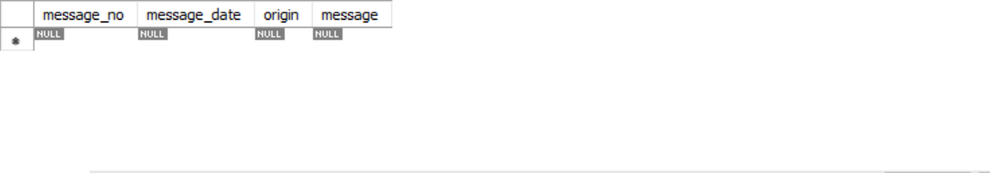



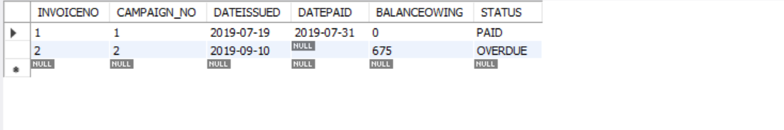



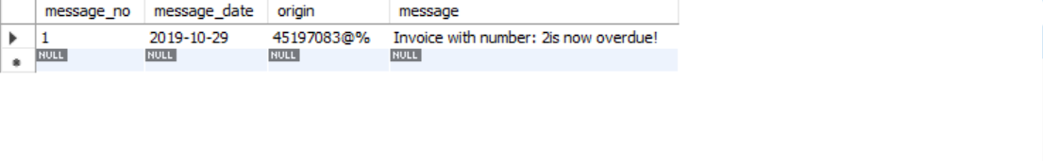

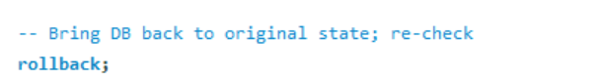

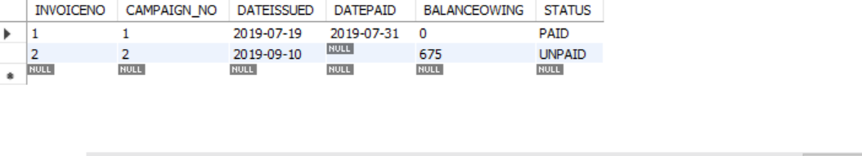





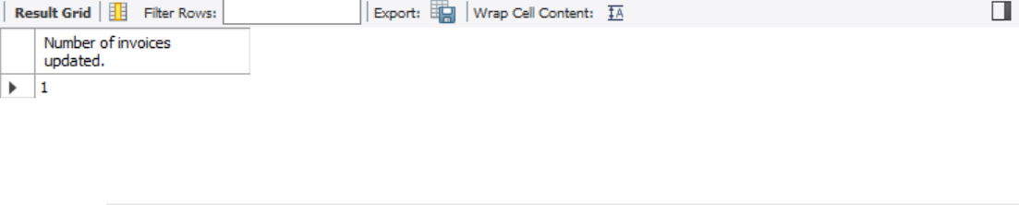



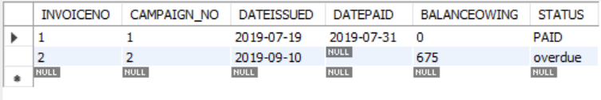



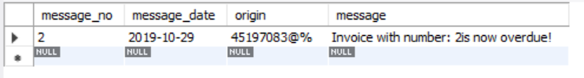

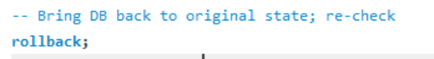



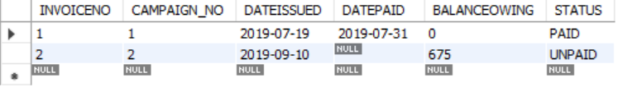



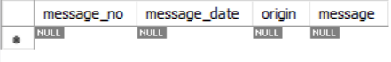





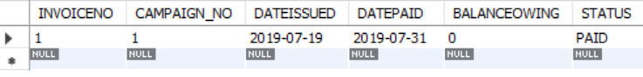



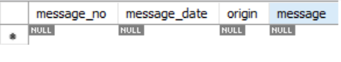



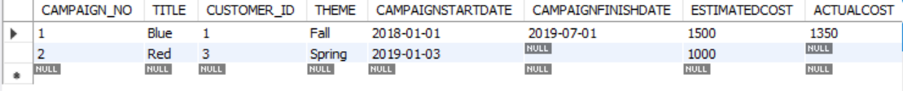



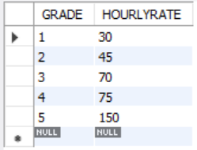



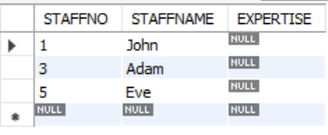

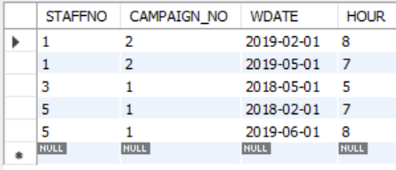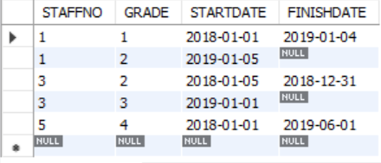



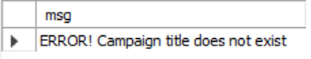



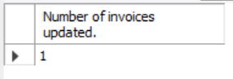



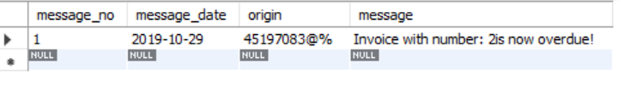

1. **More Extensive Testing.**

*Explain what changes you made to which tables, what tests you ran, and why. Copy and paste from your file <yourLastname_yourFirstname>_test_script.sql the DML statements you used for this purpose, followed by the screenshots of the records in those tables. Then copy and paste the procedure calls you made, and the screenshots of the records in the relevant tables (or the error messages).*

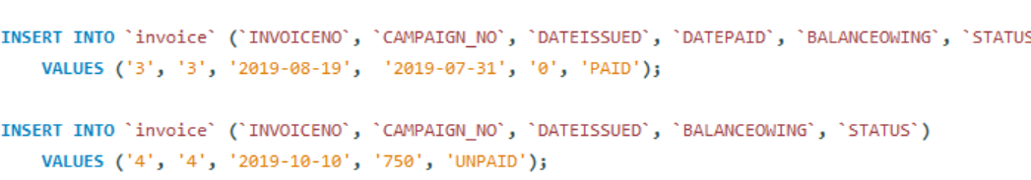

More data are more inserted to test out whether the trigger is working or not.

**Acknowledgement**

I would like to acknowledge the following people for their help through discussions.

* Matt De Masi
* Cheryl Tran
* Renáta Szabolcsik
* Isobel Ford